SIMATS ENGINEERING (SAVEETHA SCHOOL OF ENGINEERING)
Department of Computer Science and Engineering

ASSESSMENT TOOL 1 – SAST SIMULATION

Course Code: | CSA5802 | Course Title: | DEVSECOPS ENGINEERING AND APPLICATION SECURITY
CO Assessed: | CO3 – Precision (BL1, BL2, BL3) | Assessment: | Assessment Tool 1
Weightage: | 30% of CIA | Total Marks: | 100
CO3 Statement: | Simulate Static Application Security Testing (SAST) using synthetic data
Student Name: | Y.Devi priya | Reg. No.: | 192465042
Section / Batch: | Cse cyber security | Date: | 10-08-2026
Instructions to Students

- Ensure all diagrams and workflow illustrations are original, clear, and professionally formatted.
- Include all editable source files (such as .yml, .py, requirements.txt, .pre-commit-config.yaml, and any diagram source files if applicable).
- Submit both the GitHub repository link and the final PDF report through Google Classroom before the specified deadline.
- Verify that the GitHub repository is accessible and contains all required project files, screenshots, and documentation.

Question Type | Focus Area | Questions | Marks
SAST SIMULATION | Creative Things and concept grasping | Q1 | Q1 –100
GRAND TOTAL: |  | 100 Marks

Code of Conduct
I N D YOGESHWAR certify that this submission is my original work and that I have adhered to the guidelines specified for this assessment. I understand that any violation of academic integrity rules will result in disciplinary action.
Signature of the Student: N D YOGESHWAR

RUBRICS FOR CALCULATION

Criteria | Wt. | Level 4 – Exemplary | Level 3 – Proficient | Level 2 – Developing | Level 1 – Beginning
Understanding of Problem Context | 20% | Clearly understands the problem and accurately identifies all requirements | Good understanding with minor gaps | Basic understanding; some requirements unclear | Poor understanding or misinterpretation of the problem
Application of Concepts | 30% | Accurately applies appropriate concepts to solve complex problems | Applies relevant concepts correctly with minor errors | Applies basic concepts with limited accuracy | Fails to apply appropriate concepts
Problem-Solving Approach | 20% | Logical, well-structured, and efficient approach | Mostly logical approach with minor gaps | Basic approach with some inconsistencies | Illogical or unclear approach
Accuracy of Solution | 20% | Completely correct solution with proper justification | Mostly correct with minor errors | Partially correct solution | Incorrect or incomplete solution
Clarity | 10% | Clear, well-organized, and properly explained solution | Understandable with minor clarity issues | Limited clarity and explanation | Poorly presented and difficult to understand

Rubrics:
Criteria | Weightage | Awarded Marks | Total  Marks (100)
Understanding of Concepts | 25%
Experimental Design | 30%
Use of Tools | 20%
Analysis of Results | 15%
Documentation | 10%
Total per Question | 100 Marks
──── 100
Faculty In-charge | Course Coordinator | Head of Department
Signature: | Signature: | Signature:
Date: | Date: | Date:

Step 1 — Set up environment
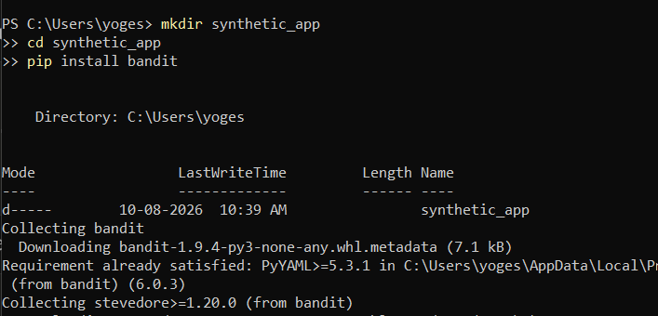

Step 2 — Create the vulnerable file
Open Notepad or VS Code, paste this, save as user_lookup.py inside the synthetic_app
folder:
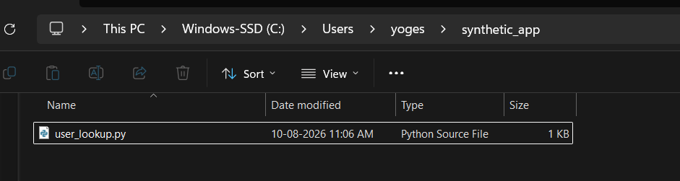

Step 3 — Run the scan
From inside the synthetic_app folder:

Powershell

bandit -r . -f txt
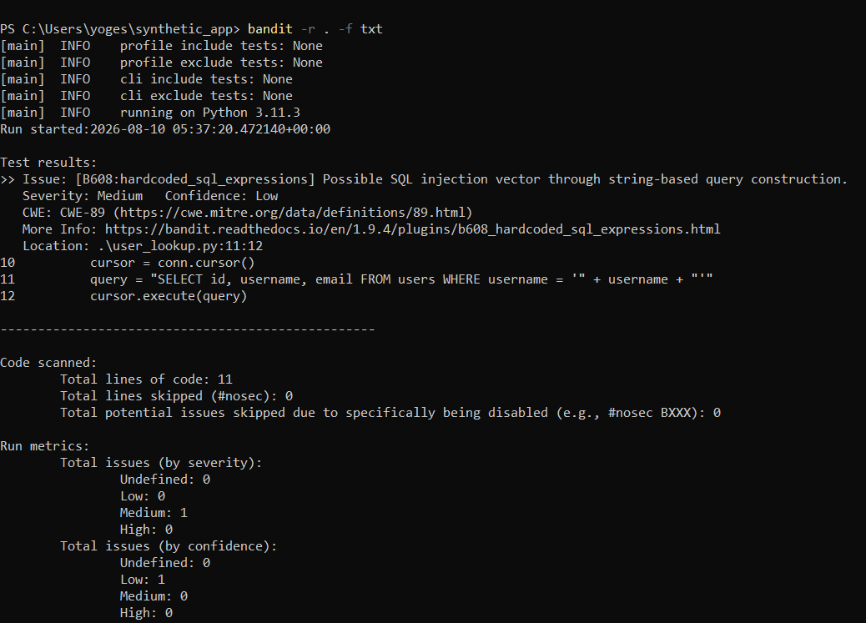

Step 4 — Read the output
Same as before — issue type, severity, confidence, CWE-89, file/line, code snippet.

Step 5 — Save evidence

Powershell

bandit -r . -f json -o bandit_report.json
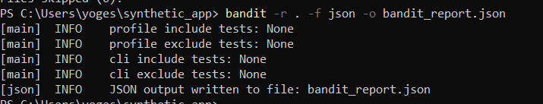

Step 6 — Fix and re-scan
Edit the line to:

Python

query = "SELECT id, username, email FROM users WHERE username = ?" cursor.execute(query, (username,))

bandit -r . -f txt

